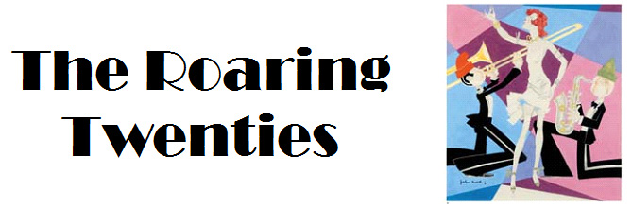
Name _________________________________________________ Date __________________

Task:
- Look and listen for the answers to the questions below as you view this video presentation at the following link: www.mrvanduyne.com/20s/20sStations/stations2011.htm
- Fill in the answers below.
- Include your name, print and turn your work in. If your computer will not print, email it to cookd@tunicak12.org

1. Why did workers go on strike in the years after World War I?
2. Why did many Americans fear the labor unrest of the post-war years?
3. What “pledge” helped Warren G. Harding win the presidential election of 1920?
4. Who was elected president in 1924?
5. How many automobiles were registered in the U.S. by the end of the 1920’s?
6. What other industries were helped by the growth of the automobile industry?
7. Why did farmers have a hard time in the 1920’s?
8. What made “buying” easy in the 1920’s?
9. Why did Charles Lindbergh become an American hero in the 1920’s?
10. What did Lindbergh’s flight lead to?
11. Why did many Americans fear immigrants in the years after World War I?
12. What people was the “new” Ku Klux Klan against?
13. Who became a leader of a black “separatist” movement in the 1920’s?
14. What religious/scientific argument that began in the 1920’s is still in the news today?
15. What was the goal of Prohibition? How successful was it?
16. What truly American form of music became popular in the 1920’s? Where did it begin?
17. Why were radios so popular during the 1920’s?
18. What event signaled the end of “the Roaring 20’s?”

